Sample sheet (outer cover)

**Blood Donation Website**

Minor Project

**BACHELOR OF COMPUTER APPLICATION**

(BCA)



**SUBMITTED BY:**

Name: JAYANT

Rollo:2020397

OCT, 2022

**Under the Guidance of**

MRS.RUCHI

Designation of mentor

**Department of Computer Application**

**Chandigarh School of Business**

**Jhanjeri, Mohali - 140307**

**Table of Contents**

|  |  |  |
| --- | --- | --- |
| **SNo** | **Contents** | **Page.No** |
| 1. | Introduction |  |
| 2. | Brief Literature survey |  |
| 3. | Problem formulation |  |
| 4. | Objectives |  |
| 5. | Methodology/ Planning of work |  |
| 6. | Facilities required for proposed work |  |
| 7. | References |  |

**Chapter 1**

**Introduction**

**1.1 What is Blood Donation?**

Blood donation is a medical procedure for giving the blood. If anyone wants to donate blood, he can easily donate. It is beneficial for those people who need blood in any problem like: Road Accident .This situation is created during the accident when blood is lose in body. Blood is the most important body fluid in the body of any living organism. It is this important body fluid which delivers all the necessary and essential nutrients and substances to all the other parts of the human body. This is the basic reason why blood donation assumes an important requirement of life.

**1.2 Scope of Blood Donation**

1. For Solving blood problem.

2. Time to Time give blood for patients.

3. For Saving Maximum life.

4. Possible proper treatment.

5. Proper usage of blood.

6. Minimum unwanted or low death rate.

**1.3 Described work**

I made blood donation website. In this website I attached a registration form and login form for visiting website successfully. After Login, we jump yo home page. In home page all details are attached in this page with blood donation form and contact form. If user want to check the registration details and blood donation detail then those are also available in this website. For making this website, I used HTML, CSS, JAVASCRIPT , PHP,AND MYSQL. This is dynamic website for all users, and stored data through backend in MySQL using Apache server with XAMPP software.

**1.4 Purpose of work**

1. Blood can be defined as the fluid we have in our bodies that carries oxygen form lungs to the rest of the body. It also carries waste to be eliminated form the body.

2. We have 4 to 6 liters of blood in our adult bodies depending on size . Millions of people will need blood this era. There are thousands of pints of blood that are needed every day to help people.

**Chapter 2**

**Hardware Softwar**

**Requirements with Modules**

**Hardware and Software Requirements:**

**Hardware:**

1.Ram=512MB and 1GB expected

2.CPU=i3 processor is expected

3.Graphics=No need of Graphics Card

**Software:**

1.VS Code

2.Xampp

**Server:**

1.Apache

**Modules:**

**1.Registration Page:**

Registration Page is used for user to successfully registered in our website which means that after registration

user have permission for using this website.

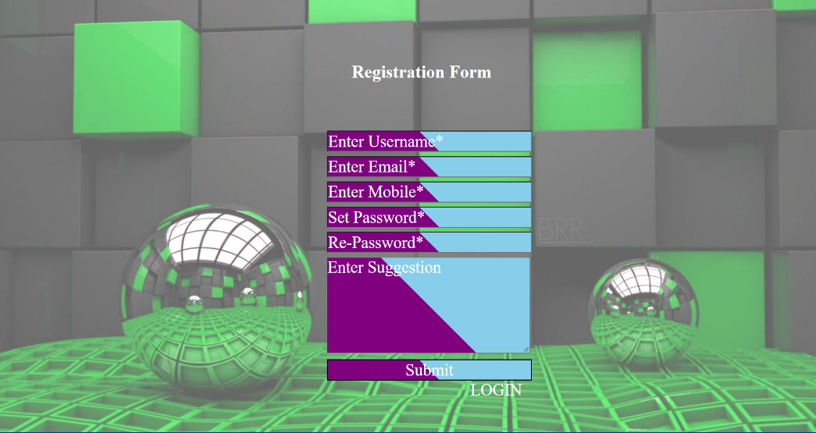

**2.Login Page:**

Login Page is used for user successfully login in our website, it means after filling email and password

go to home page and visit website in detail. It is also used for remove unauthorised person.

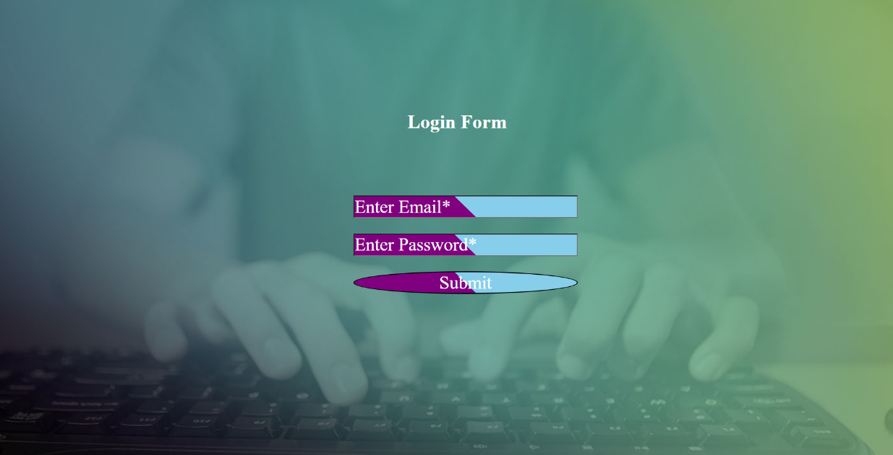

**Use of Languages**

This Website is covered two ends:1.FrontEnd and 2.Backend

Frontend

1.HTML

2.CSS

3.JavaScript

Backend

1.PHP

2.MYSQL using Xampp Server

**Chapter 3**

**Need and Significance**

**Needs**

There are many reasons patients need blood. A common misunderstanding about blood usage is that accidient victims are the patients who use the most blood. Actually, people needed the most blood include those:

1.Being treated for cancer

2.Undergoing orthopedic surgeries

3.Undergoing cardiovascular surgeries

4.Being treated for inherited blood disorders**.**

**Significance:**

Blood donation **keeps the patient alive** by providing a supplementary blood transfusion activity so that they can live a longer life instead of dying from blood loss. In our society with respect for the donor, blood donation is important because it help to replace old blood products into new blood products.

**Chapter 4**

**OBJECTIVES**

1. For Solving blood problem.

2. Time to Time give blood for patients.

3. For Saving Maximum life.

4. Possible proper treatment.

5. Proper usage of blood.

6. Minimum unwanted or low death rate**.**

**Chapter-5**

**Planning of Work**

1.Firstly I create a registration form using HTML and CSS.

2. I create a Login form,for successfully login the user.

3. Create Home Page with navigation bar,summary of Blood Donation.

4. Inside the Home,attach the registeration page for donars have successfully give details for blood donation.

5.End of the Home Page ,attach footer for giving details and with contact us like twitter account,gmail and so on.

6. If User want to check our registed details ,this is also available in our Website.

7. Lastly all created forms connected with database using PHP and MYSQL database**.**

**Chapter 6**

**Facilities**

1.No Leak your data

2.Own details Checking Facilities are also available

3.Provide blood for Needed people.

4.Secured you data from Unwanted Person

5.24 hours service available on Internet

6. In this Website , no need to pay any money or fees for registration or something else.

7.Giving Proper and all Information in our Website.

**References**

1. <https://www.medindia.net/patients/patientinfo/blooddonation-references.htm>

2. [(4882) How to Make Login Form in PHP and MySQL - YouTube](https://www.youtube.com/watch?v=aIsu9SPcGbU&ab_channel=OnlineITtutsTutorials)

3. [(4882) User Registration Form with PHP and MySQL Tutorial 1 - Creating a Registration Form - YouTube](https://www.youtube.com/watch?v=00Thb3oPJ74&ab_channel=ProgrammingKnowledge)